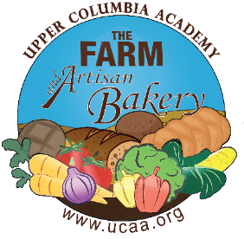
Please email order form directly to bakery@ucaa.org by DEADLINE of 11am each MONDAY for a WEDNESDAY same week pick up.
- Weekly Pickup Location/Time: UCA Farm Stand, 3025 E. Spangle Waverly Rd., Spangle every Wednesday between 1-4pm. Farm stand closes at 4:30pm.
- You will receive an invoice via email to pay online with a credit or debit card. Please pay prior to pick-up. Thank you! UCA STAFF: all orders will be charged to your UCA account
- We will not be taking orders the weeks of November 21, December 19 or December 26,
March 20 or June 5.

Name: Phone: Email:
Baked Good | Price | Quantity | Total Price
BAGELS – pack of 6
Cheddar | 8.50
Cheese Pizza | 8.50
Jalapeno (vegan) | 8.50
Jalapeno Cheddar | 8.50
Sourdough /Plain (vegan) | 8.50
Tomato Basil (vegan) | 8.50
COOKIES
Chocolate Chip | 2.50
Molasses | 2.50
SWEET TREATS
Cinnamon Roll with Cream Cheese Frosting | 5.00
Cinnamon Roll with Vanilla Icing (vegan) | 5.00
Pecan Sticky Bun | 5.00
SOURDOUGHS
Country White Sourdough Bread (vegan) | 7.00
Multi-grain Sourdough (vegan) | 7.00
Roasted Garlic & Rosemary (vegan) | 8.50
Sourdough English Muffins (vegan) – pack of 6 | 6.00
Toasted Pecan Raisin Sourdough (vegan) | 8.50
SANDWICH LOAVES
Maple Oat Bread (vegan) | 7.00
Whole Wheat & Honey Loaf  (vegan with exception of the honey) | 7.00
FOCACCIA
Herb (vegan) | 8.50
Herb, Garlic & Cheese | 8.50
Jalapeno Cheddar | 8.50
Roasted Garlic & Rosemary (vegan) | 8.50
ORGANIC
Country White Sourdough Bread  (organic/vegan) | 9.00
Maple Oat Bread (organic/vegan) | 9.00
Multi-grain Sourdough Bread (organic/vegan) | 9.00
SCONES
Chocolate Chip | 4.00
Coconut (vegan) | 4.00
Lemon Currant (vegan) | 4.00
Lemon Poppyseed | 4.00
Grand Total | $

