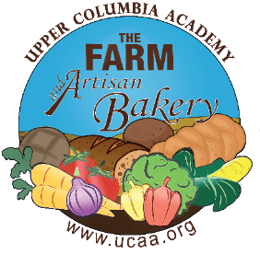
- Pre-order service starts Monday, June 13th for first pick-up on Wednesday, June 15.
- Please email order form directly to bakery@ucaa.org by DEADLINE of 11am each MONDAY for a WEDNESDAY same week pick up.
- Weekly Pickup Location/Time: UCA Farm Stand, 3025 E. Spangle Waverly Rd., Spangle every Wednesday between 2-3pm. Farm stand closes at 4pm.
- You will receive an invoice via email to pay online with a credit or debit card. Please pay prior to pick-up. Thank you! UCA STAFF: all orders will be charged to your UCA account
- We will not be taking orders the week of July 4th

Name: Phone: Email:
Baked Good | Price | Quantity | Total Price
BAGELS – pack of 6
Cheddar | 7.00
Cheese Pizza | 7.00
Jalapeno (vegan) | 7.00
Jalapeno Cheddar | 7.00
Sourdough /Plain (vegan) | 7.00
Tomato Basil (vegan) | 7.00
COOKIES
Chocolate Chip | 2.00
Molasses | 2.00
Gluten Free/Vegan Chocolate Chip  (almond flour, organic maple syrup, organic coconut oil,  organic/vegan chocolate chips, baking soda, salt) | 1.00
SWEET TREATS
Cinnamon Roll with Cream Cheese Frosting | 4.00
Cinnamon Roll with Vanilla Icing (vegan) | 4.00
Pecan Sticky Bun | 4.00
SOURDOUGHS
Country White Sourdough Bread (vegan) | 7.00
Multi-grain Sourdough (vegan) | 7.00
Sourdough English Muffins (vegan) – pack of 6 | 6.00
Toasted Pecan Raisin Sourdough (vegan) | 8.00
SANDWICH LOAVES
Maple Oat Bread (vegan) | 7.00
Whole Wheat & Honey Loaf  (vegan with exception of the honey) | 7.00
FOCACCIA
Herb (vegan) | 8.50
Herb and Cheese | 8.50
ORGANIC
Country White Sourdough Bread  (organic/vegan) | 8.00
Maple Oat Bread (organic/vegan) | 8.50
Multi-grain Sourdough Bread (organic/vegan) | 8.00
SCONES
Chocolate Chip | 4.00
Coconut (vegan) | 4.00
Lemon Currant (vegan) | 4.00
Lemon Poppyseed | 4.00
Grand Total | $

